Golang 4th assignment

Srymbetov Zhalgas

Mini Moodle

To illustrate the interactions between users and the microservices in our mini-Moodle, we'll draw a use case diagram. This diagram will show the primary actors and their interactions with the various functionalities of the system.

1.Diagram

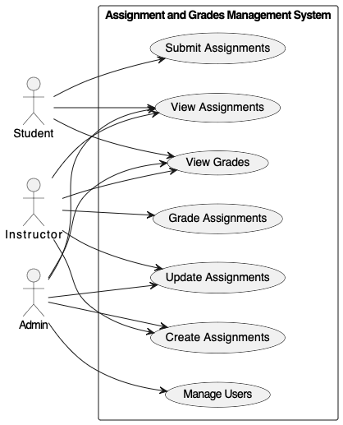

Description:

**Actors:**

* **Admin: Represents an administrator who can manage users, view assignments and grades.**
* **Instructor: Represents a teacher who can create, view, update, and grade assignments, and update grades and view grades.**
* **Student: Represents a learner who can view assignments, submit assignments, and view grades.**

**Use Cases:**

* **Create Assignment: Instructors can create and update assignments.**
* **Submit Assignment: Students can submit their assignments.**
* **Grade Assignment: Instructors can grade submitted assignments.**
* **View Assignments: Students can view available assignments.**
* **View Grades: Students can view their grades.**
* **Update Grades: Instructors can update student grades.**
* **Manage users: Handles user management by the admin.**

**Functionality of each service:**

1. View Assignments Service: Provides lists of assignments to users based on their roles. Students might see assignments they need to complete, instructors see all assignments they have created, and admins might see all assignments across all courses.
2. Submit Assignments Service: Allows students to submit their completed assignments. This might include uploading files or text entries.
3. Grade Assignments Service: Enables instructors to review submitted assignments and assign grades. This may also include providing feedback.
4. View Grades Service: Allows students to view their grades for assignments. Instructors and admins can view grades for students across different assignments and courses.
5. Create Assignments Service: Provides instructors and admins the ability to create new assignments, specifying details such as title, description, due date, and associated resources.
6. Update Assignments Service: Allows instructors and admins to make changes to existing assignments. This could include changing deadlines, assignment details, or associated resources.
7. Manage Users Service: Admins can add, remove, or modify user accounts, assign roles (student, instructor, admin), and manage access levels.

**Clean code**

**Example Mockup:**

*Mini-moodle/*

*├── cmd/*

*│ └── main.go*

*├── internal/*

*│ ├── entities/*

*│ │ ├── assignment.go*

*│ │ ├── grade.go*

*│ │ └── user.go*

*│ ├── usecases/*

*│ │ ├── create_assignment.go*

*│ │ ├── update_assignment.go*

*│ │ ├── submit_assignment.go*

*│ │ ├── grade_assignment.go*

*│ │ ├── view_assignments.go*

*│ │ └── view_grades.go*

*│ ├── interfaces/*

*│ │ ├── controllers/*

*│ │ │ ├── assignment_controller.go*

*│ │ │ ├── grade_controller.go*

*│ │ │ └── user_controller.go*

*│ │ ├── presenters/*

*│ │ │ ├── assignment_presenter.go*

*│ │ │ ├── grade_presenter.go*

*│ │ │ └── user_presenter.go*

*│ │ └── repositories/*

*│ │ ├── assignment_repository.go*

*│ │ ├── grade_repository.go*

*│ │ └── user_repository.go*

*│ └── frameworks/*

*│ ├── database/*

*│ │ └── db_connection.go*

*│ ├── webserver/*

*│ │ └── router.go*

*│ └── auth/*

*│ └── jwt.go*

*└── README.md*